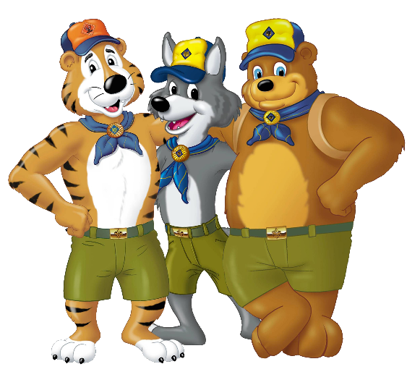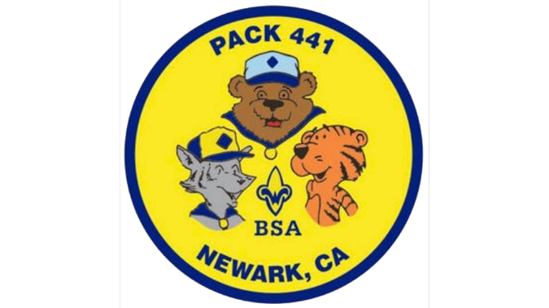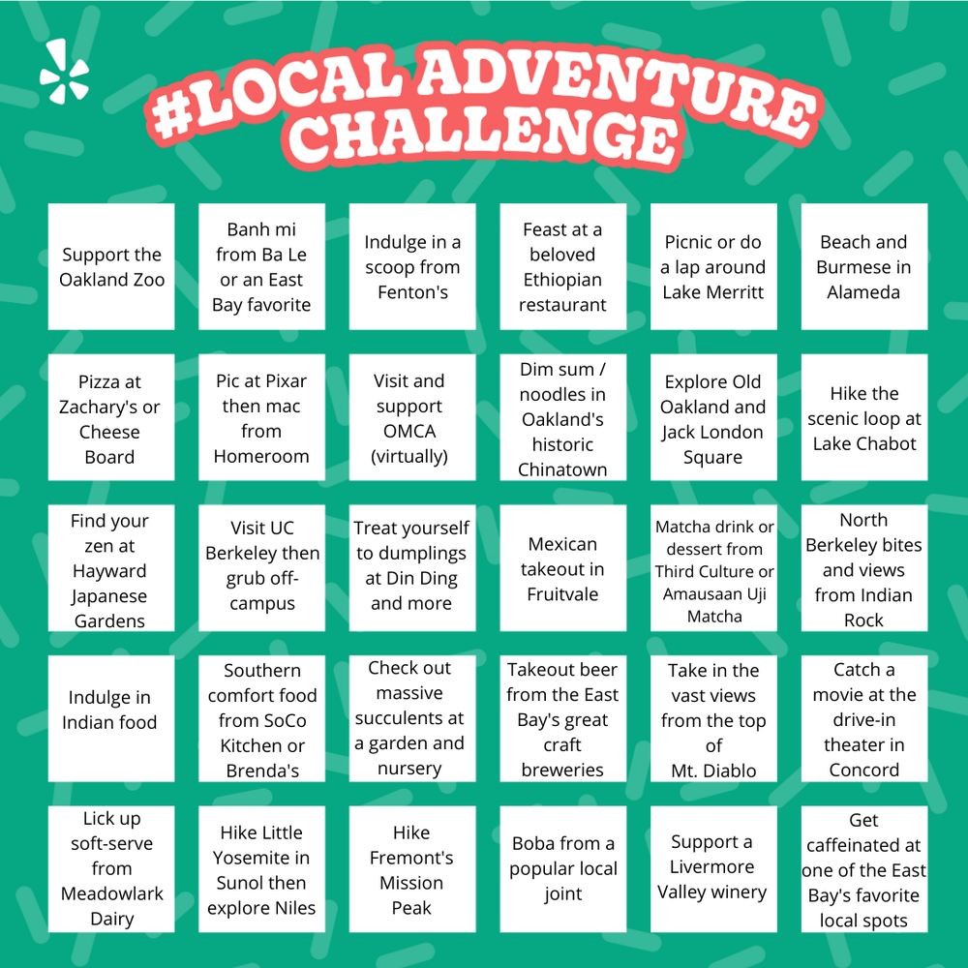

Final Date is January 31, 2021. There will be prizes for the scouts who did the most activities with 1st place - $50 Amazon Gift Card, 2nd Place - $30 Amazon Gift Card, and 3rd Place - $20 Amazon Gift Card. Must have photo proof of all activity for validation.

Check out the Niles Canyon Railway in Sunol

Check out massive succulents at a garden or nursey

Take a vast view from the top of Mt. Diablo

Order Food from a Mexican Food Truck

Hike the scenic loop at Lake Chabot

Write a Handwritten Letter to an elder in your family

Help cook a family dinner by making at least one dish

Match a drink or Boba at a local Boba store

Indulge in Indian Food

Hike Little Yosemite in Sunol then explore Niles

Take a family hike in Garin Park

See the Indian Archaeological site at Coyote Hill

Go inside the enormous rocks at Rock City at Mt. Diablo

Hike around Lake Elizabeth & make new furry friends at the dog park

Attend virtual family comedy night with Made Up Theatre

Volunteer for a Food Drive such as Scouting for Food

Help clean up your front/back yard for Fall

Try Creole Food at Craw Daddy in Milpitas

Go on a 3 miles bike along the Alameda Creek Trail

Take a 3 mile bike ride along the Coyote Hill Coastline

Write 10 Christmas Cards for Masonic Homes in Union City

Help Wash, Dry, & Fold two loads of laundry

Make new furry friends at Newbark Dog Park

Clean up trash on a 1 mile local walk

See the Giant redwood trees at Muir Woods

Visit a local museum (virtually)

Name:_________________

Do a chore to help your parents that you normally don’t do

Make a Family Movie Night with Popcorn and Pajamas

Play a new boardgame you’ve never played before

Have an overnight campout in your own backyard