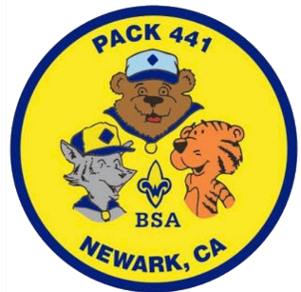
#Local Adventure Challenges
__________’s Photo Check-off List

- Go inside the enormous rocks at Rock City at Mt. Diablo
- Have an overnight sleepover in your own backyard
- Clean up trash on a 1-mile local hike
- Make new friends at the NewBark Dog Park
- Check out the Niles Canyon Railway in Sunol
- Help wash, dry and fold two loads of laundry
- Write 10 Christmas Cards for Masonic Homes in Union City
- Hike around Lake Elizabeth and make new friends at the dog park there
- Visit a local museum (virtually)
- Play a new boardgame you have never played before
- Write a handwritten letter to an elder in your family
- Hike the scenic loop at Lake Chabot
- See the Indian Archaeological site at Coyote Hills
- Attend virtual family comedy night at the Made up theater in Fremont
- See the Giant Redwood trees in Muir Woods
- Order Food from a Mexican Food Truck
- Match a drink or Boba at a local Boba store
- Help cook a family dinner by making at least one dish
- Indulge in Indian food
- Take a 3-mile bike ride along the Coyote Hill Coastline
- Check out the massive succulents at a garden or nursery
- Go on a 3-mile bike ride along the Alameda Creek Trail
- Take a vast view from the top of Mt. Diablo
- Make a family movie night with popcorn and pajamas
- Do a chore to help your parent that you normally don’t do
- Hike Little Yosemite in Sunol and then explore Niles
- Take a family hike in Garin Park
- Try Creole food at Craw Daddy in Milpitas
- Help clean up your front/back yard for Fall
- Volunteer for a Food Drive such as Scouting for food

