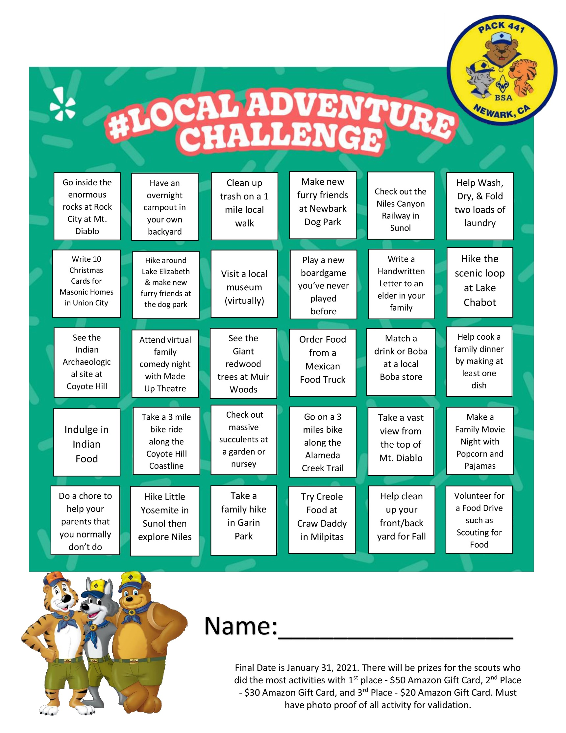

Certificate of Award

**For Participation in the Local Adventure Challenge with Newark Cub Scout Pack 441**

RECIPIENT NAME

Great job on your hard work and all the great activities you did on this list! You did a great job and everyone in our Pack is very proud of you.

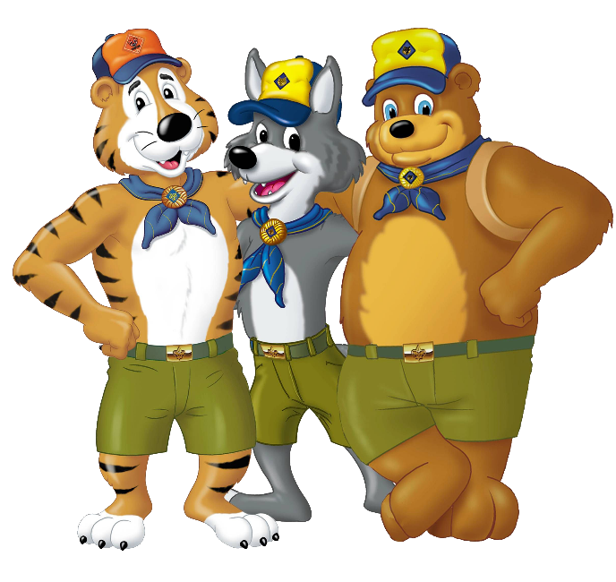

**Brian Wynn, Cubmaster**

**Date**